NAME:Rishik JK
REG.NO :192511052

CSA1702-ARTIFICIAL INTELLIGENCE
LAB EXPERIMENT

Experiment 6 – Vacuum Cleaner

AIM
To write a Python program to implement a simple Vacuum Cleaner Agent that cleans dirty rooms.

ALGORITHM
- Start the program.
- Consider two rooms A and B.
- Check the condition of Room A.
- If Room A is dirty, clean it.
- Move to Room B.
- If Room B is dirty, clean it.
- Display the final condition of both rooms.
- Stop the program.

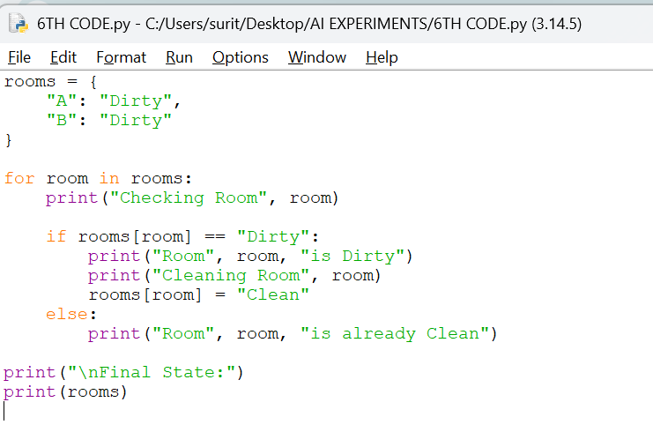
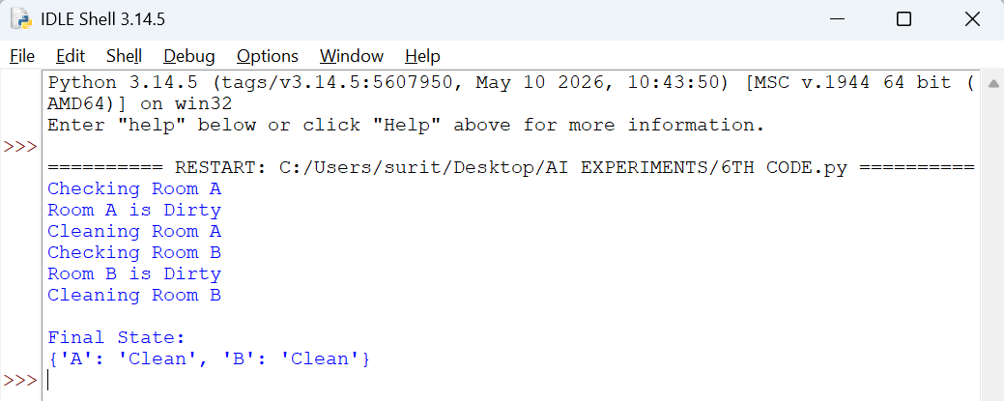

RESULT
Thus, the Vacuum Cleaner Agent was implemented successfully using Python and both dirty rooms were cleaned.

